Division(s): N/A

ITEM PF6E

PENSION FUND COMMITTEE – 26 NOVEMBER 2004

OVERVIEW AND OUTLOOK FOR INVESTMENT MARKETS

Report by the Independent Financial Adviser

- The global economy has enjoyed two years of a synchronised upswing in activity, but now sharply higher oil prices, and to a lesser extent much higher metal and soft commodity prices, are beginning to cast a shadow. Real (adjusted for inflation) oil prices are at a 20-year high, but still well below the level reached in 1981 (see chart below)

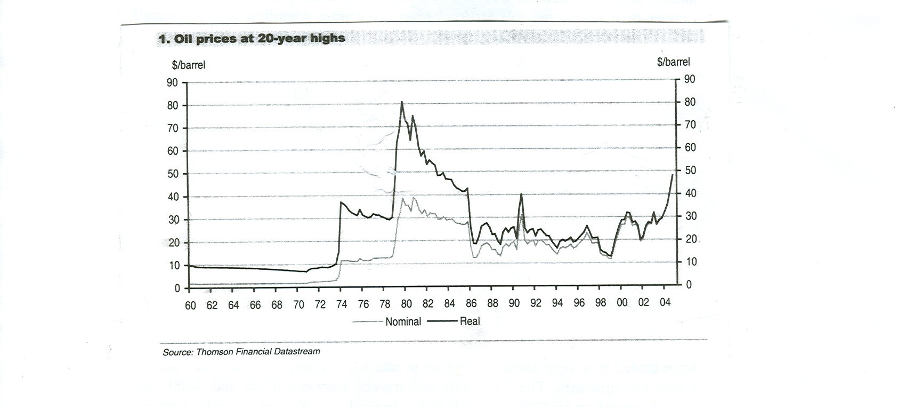

Further, the developed world is between 70% - 80% more efficient in the use of oil per unit of GDP (Gross Domestic Product) than it was in 1980. Even so, if current oil prices are maintained through the first half of 2005 global growth could be reduced by around ½% (a rise in oil prices is a transfer of wealth from developed countries in particular, to oil producing nations, who are much slower in spending an increase in income). This would reduce economic growth in the UK to around 2%, in the US to 2½% and in the EU to 1%. There is also the question whether China, where current economic growth is too fast, is able to moderate growth, without causing a hard landing, which would also impact the world economy and in particular the Asia pacific region. Assuming a soft landing, growth for China could be around 7% in 2005, 2% for Japan and 4% for the rest of Asia. Despite this, growth in the developed world could pick up in the next few months.

- The rise in oil prices has been driven by a sharp increase in demand and concern over supply. The synchronised global recovery, coupled with a rise of 40% in Chinese use of oil this year, has lifted demand while the failure of Iraq’s production to recover, uncertainty in Russia’s oil industry, fears of terrorist attacks in Saudi Arabia, instability in Venezuela and strikes in Nigeria have caused concern over supply. There is also a speculative element of may be $5 - $10 in the price as hedge funds and others have taken a position in the market. If just some of these factors moderate and speculative positions are unwound, the price could fall significantly. Even so the natural price of oil has probably risen to around $28 - $32, compared with a current price of $44 and a recent peak of $50 in Brent crude.

- There are other factors that weigh on investment markets. In the UK the level of house prices and of personal debt, both mortgage and non-mortgage, has been of concern. The Bank of England has lifted interest rates from 3½% to 4¾% in five steps, and there may be a further rise to 5%. House prices have stalled and now just turned negative. They are clearly overvalued and the danger of a protracted fall could damage consumer spending and so overall economic growth. House prices have also risen rapidly in the US, added to which personal debt is very high, the government budget deficit is enormous and the balance of external payments on current account is now 5% of GDP and rising. At some point these imbalances in the US economy will have to be corrected, which will impact economic growth. Even so, the US Federal Reserve will probably continue lifting interest rates from the current 2% to at least 2½% by mid 2005, which is still below a neutral rate. The EU, with its rigid labour and other markets and poor demographics, seems to be locked into a lower rate of economic growth. The European Central Bank will probably keep rates on hold at 2% for sometime, particularly as the Euro has risen, thereby tightening monetary policy, which could justify a reduction in interest rates.

Markets

- Most equity markets, apart from Japan and some other markets in the Far East, have traded in a very narrow range up to late September, when the UK market broke out upwards. The FTSE100 had moved between 4300 and 4600, but then it moved up to 4780. The All Share Index has followed a similar pattern. With consensus profit growths of 8% for 2005 the market stands on a prospective price earnings ratio of 12.5, which is not expensive, and so the market may rise modestly further with the normal seasonal end year rally. The US market started the year close to its peak for the year with the Dow Jones at 10,737 and has since traded between that and 9750. Currently it is around 10,400 and might be expected to participate in an end year rally, but it is overvalued on a prospective price earnings ratio of 18 – 20. Any rally in European markets may well be muted with a background of low growth and a hardening Euro. The prospects for Western equity markets for 2005 indicate it could be a difficult year. With the maturing cycle profit growth momentum will be slowing, particularly in the U.S. where the share of profits in national income has reached a record level. Further, markets will be depressed if the oil price does not come back in the first quarter, when seasonally it tends to be weaker with the completion of stocking for the northern hemisphere winter. Also by then the trend in house prices in both the U.K. and the U.S. will become clearer, while in the U.S. the market could start to focus on the problem of the twin deficits, the budget and the current account. In the Far East much will depend on whether China achieves a soft landing, although in Japan the recovery is broadening out from exports while restructuring is taking place at company level, so the market could make progress.

- Bond yields have drifted back from the highs reached in the middle of the year, when there were fears of rising inflation, with the U.K. ten-year benchmark yield declining from 5.2% to the current 4.7%. Those of the U.S. and Germany have trended in the same direction to the current 4.2% and 3.8% respectively. At present markets are only expecting oil prices to result in marginally higher inflation, because of competitive pressures, but with short term interest rates still expected to rise modestly and with an increasing supply of government debt to finance the budget deficits, particularly in the U.S.A., but also in the U.K. and the E.U., bond yields could be under upward pressure. U.S. bond yields are especially vulnerable if Asian central banks reduce the investment of export earnings in the U.S. Treasuries, thereby financing the U.S. current account deficit.

- The U.S. dollar will probably continue to weaken with the massive supply of dollars from the current account deficit. Sterling has risen from $1.79 at end December to the current of $1.86, the euro from $1.26 to $1.29 and the Japanese Yen from Yen 107 to Yen 105, but sterling, with the peak of the interest rate cycle in sight, has already fallen from €1.50 to €1.43 and from Yen 205 to 195 and could decline further.

- Charts of the U.K. and U.S. stock markets and of currencies and oil are attached.

A.F.Bushell
Independent Financial Adviser
November 2004

